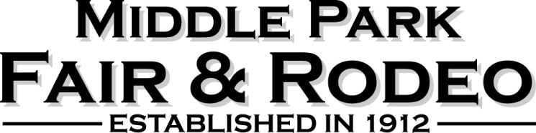

The meeting was called to order at 6:30 pm, October 18, 2022
Present at the meeting were Fair Board Members: Janet Engel, Mari Miller, Christy Horn, Seth Stern
Audience members were Terry Pratt, Tish Linke, Travis Wood, Kris Makowski, Ana Etler, Micah Benson

Approval of Minutes from Regular Board Meeting on October 4, 2022, Mari moved to approve, Christy second, passed

Approval of Expenditures – Staats Ribbons $253.44 for correction of the bid from Oct 4, Northwest Ranch Supply $ $349.98 Ear Tags for weigh-in, Mari motioned, Seth second, passed
- Not approved $220, Thirsty Dills, for Buyers Dinner as this amount was included and paid in the original quote of $1500, which was paid on September 19, 2022
- Going forward we would like quotes from him

Seth led a discussion regarding how we must be better about contracts and doing things properly, not at the last minute. We need to give more forethought to what we do. More planning.

Discussion regarding the royalty program – Juli Sanders and Kristi Moyer feel that something should be done for the princess as she attends all the events the queen does and gets nothing in return for their time. Perhaps $250, Mari suggested some sort of scholarship, Seth suggested maybe a money market account in their name.
FB would like to hear more ideas from them

Budget discussion – Christy motioned to approve the budget markers done by the county in the amount of $160,000 for MPF&R and expenditures of $155,000. The livestock account for $430,000 and expenditures of $385,000 Christy motioned to approve, Mari second, passed

Bylaws – there are some grammatical mistakes that need to be corrected. The bylaws need to be posted for 30 days on our website, and Facebook and the county will link to us. After allowing for 30 days of public comments then the board will approve the bylaws and will go to BOCC for formal approval.

Fair Board Interviews will be on November 15th starting at 5:30 pm. Interviews will be 20 minutes long, with a 5-minute break between applicants. Mari will send a sign-up for an interview time to the applicants.

Motion was made by Seth to approve Terry Pratt for the board and as Treasurer. Mari second, passed

CSU Extension MOU discussion was tabled until we can talk to Olivia Clark, before she leaves on Nov 11.

Mari motioned to have the Livestock Sale Account come back under the auspices of the Fair Board. Seth second, motion passed.

Miscellaneous notes and comments
Discussion of suggestions from comments from 4-H parents, superintendents, and the fair board on how to improve the efficiency of the fair.
Maybe talk to FFA/Welding shop at the high school about making feeders for the livestock pens.
New water tanks have been purchased and will be locked to the pens as theft has been a problem in the past.

Janet suggested adding historical fair pictures to the walls in the dance hall. GCHA has some great ones and Micah said she found a new storage room at the courthouse that has pictures.

The processor for this year has been secured and we will need to lock in the processor for 2024 by the first of November.

Tish Linke is confirmed for Round Robin Superintendent but does not want to have small animals included in Round Robin as it is too hard on them.

Adjournment at 8:06 pm Seth motioned, Mari Second

Next Meeting – November 1st, 6:30 pm BOCC lunchroom, Hot Sulphur*
*Due to BOCC Meeting Room set up for elections*

