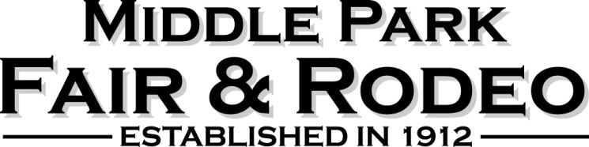

The Middle Park Fair & Rodeo Board will accept nominations for appointment at any time. The board will review and forward recommendations for appointment or re-appointment to the Grand County Board of County Commissioners to fill vacancies as well as when existing board member terms expire.

Name: ___________________ Date: _______________________

Mailing Address: ____________________________________________

City: ____________________ State: ______ Zip: ________

Cell: ____________________ Email: ______________________

Are you an employee of Grand County? Yes: _____ No: _________

What district do you reside in? _____ #1 (Winter Park/Fraser/Tabernash)
_____ #2 (Granby/Grand Lake)
_____ #3 (Hot Sulphur/Parshall/Kremmling)

How long have you been a resident of Grand County? ______

Please answer each question giving your thoughts, ideas, and opinions. (If additional space is needed, please attach additional pages.)

Are you currently a member of any other board in Grand County? If yes, please describe your position and length of membership:
______________________________________________________________________________________________________________________________________________________________________________________________________________________________________________________________________________________________________________________________________________________________

Have you ever been a member of the MPF&R board of directors? If yes, please describe your position and length of membership:
______________________________________________________________________________________________________________________________________________________________________________________________________________________________________________________________________________________________________________________________________________________________
Are you currently involved as a committee member, 4-H program, or any other volunteer position associated with the MPF&R? If yes, describe:
______________________________________________________________________________________________________________________________________________________________________________________________________________________________________________________________________________________________________________________________________________________________

Why are you interested in being a MPF&R board member? Please include any skills, ideas, or experiences that you feel are important to your potential position on the board:
______________________________________________________________________________________________________________________________________________________________________________________________________________________________________________________________________________________________________________________________________________________________

What is your vision of the MPF&R for the next 3 years?
______________________________________________________________________________________________________________________________________________________________________________________________________________________________________________________________________________________________________________________________________________________________

Thank you for your interest in the MPF&R! Please return this form to the Middle Park Fair & Rodeo, at MiddleParkFairAndRodeo@gmail.com or mail to PO Box 344, Kremmling, CO 80459.

