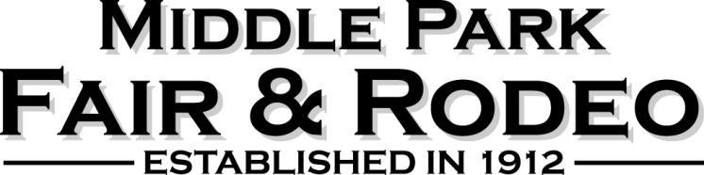

January 1, 2023
Treasurer Report

The Operating Account has a beginning balance of ________, there were deposits of ________
and _________ in cleared checks giving an ending balance $48,381.1_. We have _________
in uncleared transactions leaving a balance of after the outstanding checks clear of __________.

The Livestock Account has a beginning balance of __________, there were __________ that
cleared and _________ in deposits making the ending balance $54,172.34. There are _________
in uncleared checks making the balance after the outstanding checks clear _____________.

The Scholarship Account has a balance of $5,534.36with no outstanding checks.

Bills that need board approval:

Operating Account
CPRA Sanction Agreement - $125
Airbound 50% deposit - $8,027.50
Winter Park Chamber of Commerce - $200.00
Triple V Designs $32.25

Total $8,384.75

Invoice previously approved for Staats Ribbons –$2,705.85

Livestock Account
Mari Miller – Champion Banner - $39.40
Sagebrush BBQ & Grill – Buyers Dinner deposit - $2,376.70

Total $2,416.10

Motion to process payments __________________ Second ____________________

